
The ABCDE
of Rights
United Nations Convention on the Rights of the Child
Every child has rights.
Rights belong to children simply because they are children.
  BE HEARD |   LEARN |   PLAY |   BE SAFE |   BE CARED FOR

Children are Rights Holders. Adults are Duty Bearers.

Whitecross Primary School and Nursery Class
A
ALL CHILDREN
Rights are for ALL children.
UNIVERSAL
Every child, everywhere, has the same rights.
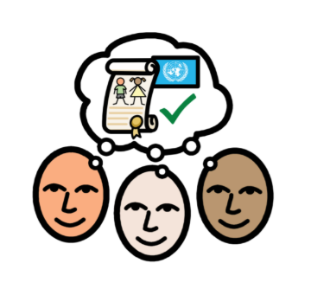
Whitecross Primary School and Nursery Class
B
FROM BIRTH
Rights are there from BIRTH.
INHERENT
Children have these rights from the moment they are born.
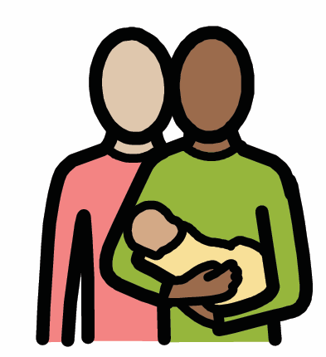
Whitecross Primary School and Nursery Class
C
CANNOT BE TAKEN AWAY
Rights CANNOT be taken away.
INALIENABLE
No person can remove a child’s rights.
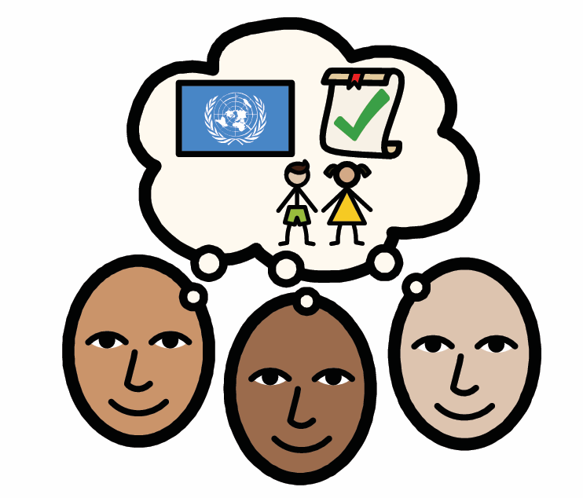
Whitecross Primary School and Nursery Class
D
DO NOT HAVE TO BE EARNED
Rights DO NOT have to be earned.
UNCONDITIONAL
Rights are not rewards, and children do not lose them through their behaviour.
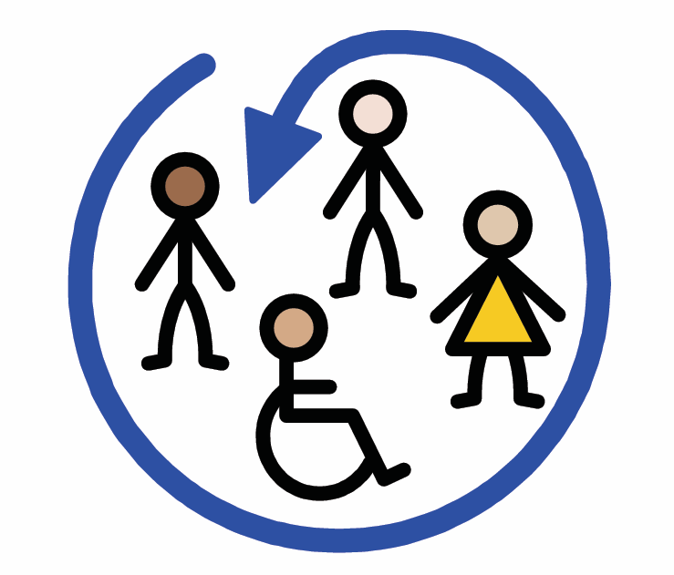
Whitecross Primary School and Nursery Class
E
EQUALLY IMPORTANT
All rights are EQUALLY important.
INDIVISIBLE
Every right matters. Rights are connected and cannot be separated.
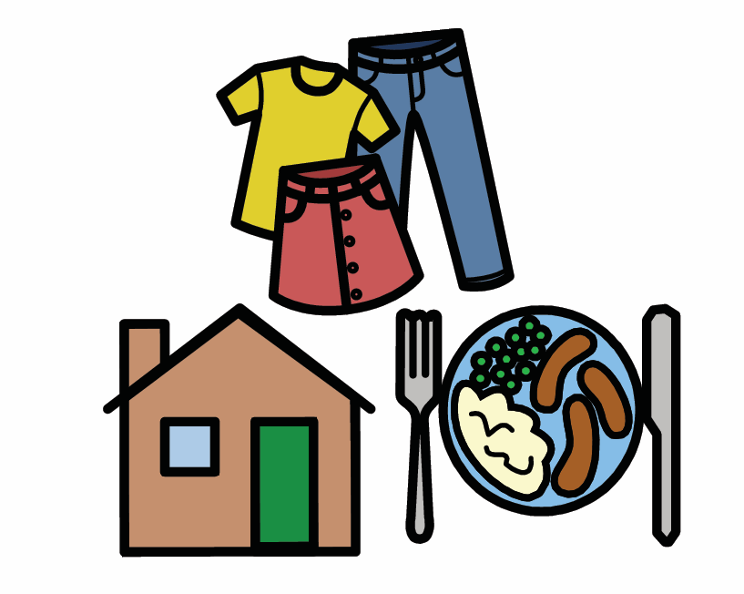
Whitecross Primary School and Nursery Class
Children are
Rights Holders
Every child has rights under the UNCRC.
RIGHTS HOLDERS
Children and young people under 18 are Rights Holders. Their rights are theirs from birth and do not have to be earned.
At Whitecross, children learn about their rights, use their voice and respect the rights of others.
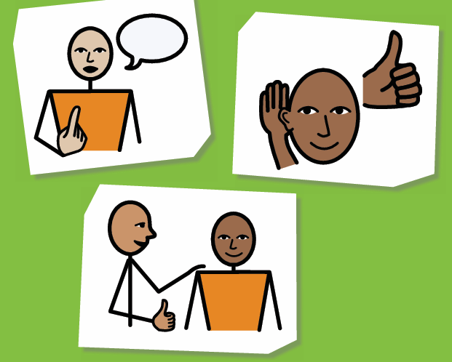
Whitecross Primary School and Nursery Class
Adults are
Duty Bearers
Adults have responsibilities to uphold children’s rights.
DUTY BEARERS
Parents, carers, school staff, governments, councils and organisations are Duty Bearers. They must respect, protect and fulfil children’s rights.
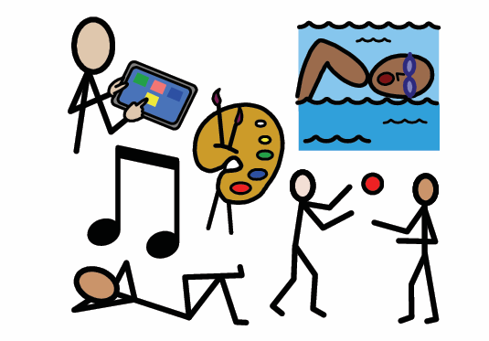
At Whitecross, Rights Holders and Duty Bearers work together to make rights real.

